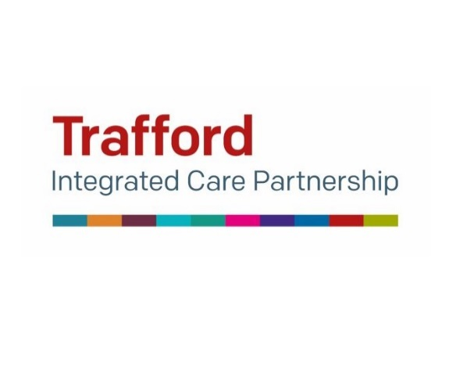

Trafford Women’s Voices Pledge
Working Collaboratively within Trafford to reduce inequalities in Women’s Health as a response to the Governments Health Strategy July 2022
By signing and returning this POWER pledge, you will agree and support the following:

Trafford POWER Pledge

- Partnership Working to promote health opportunities to underrepresented groups

- Optimize community awareness, participation, and engagement in Women’s Health Related Matters and willingness to promote public Health campaigns.

- Work in collaboration with local and Boroughwide Health Equity Initiatives, such as Trafford’s Women’s Voices and raise the voice of Trafford Women

- Empower Women to have a genuine voice about their health and care

- Respect the rights of women to design and develop services that are Women Centred and reflective of their needs.

Print Name ……………………………………………………..
Area ……………………………………………………..
Organisation/Project …………………………………………………….
Date ……………………………………………………..
Contact Details: Email: Mobile: Address:…………………………..
…………………………………………………………………………….
…………………………………………………………………………….
Please return this POWER PLEDGE to:
Shaenaaz.Ramjean@trafford.gov.uk or berni.tomlinson@trafford.gov.uk

